Upload a .html file in S3 and display it on browser

1. Go to Amazon Web Services via Quantiphi gmail
2. Click S3 under All Services/Storage
3. Click on the bucket belonging to you

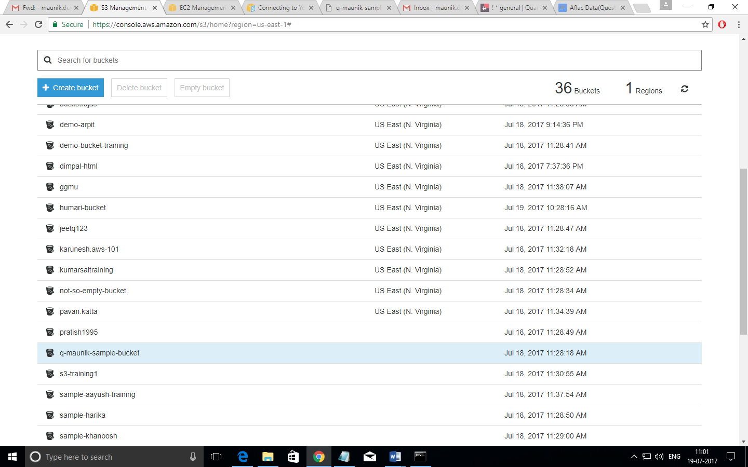

1. Click Upload and upload the .html file

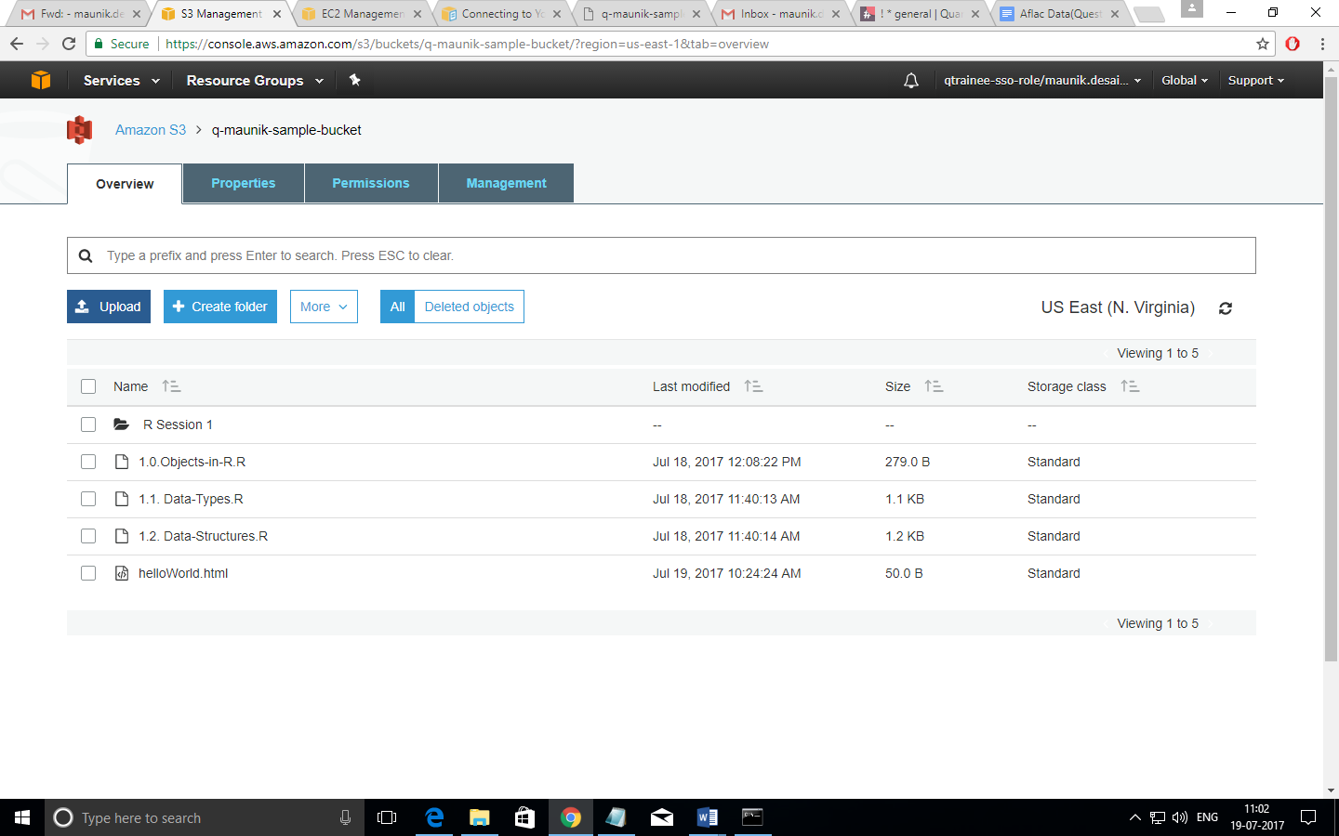

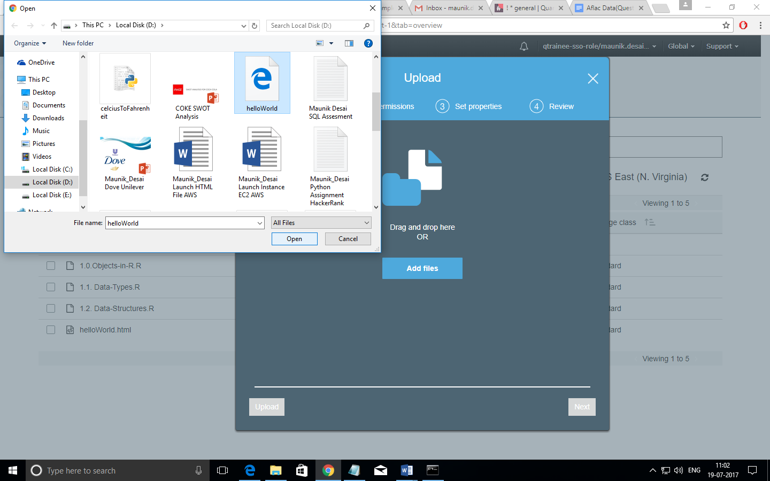

1. On successful upload, click the .html file to open the Overview of the file

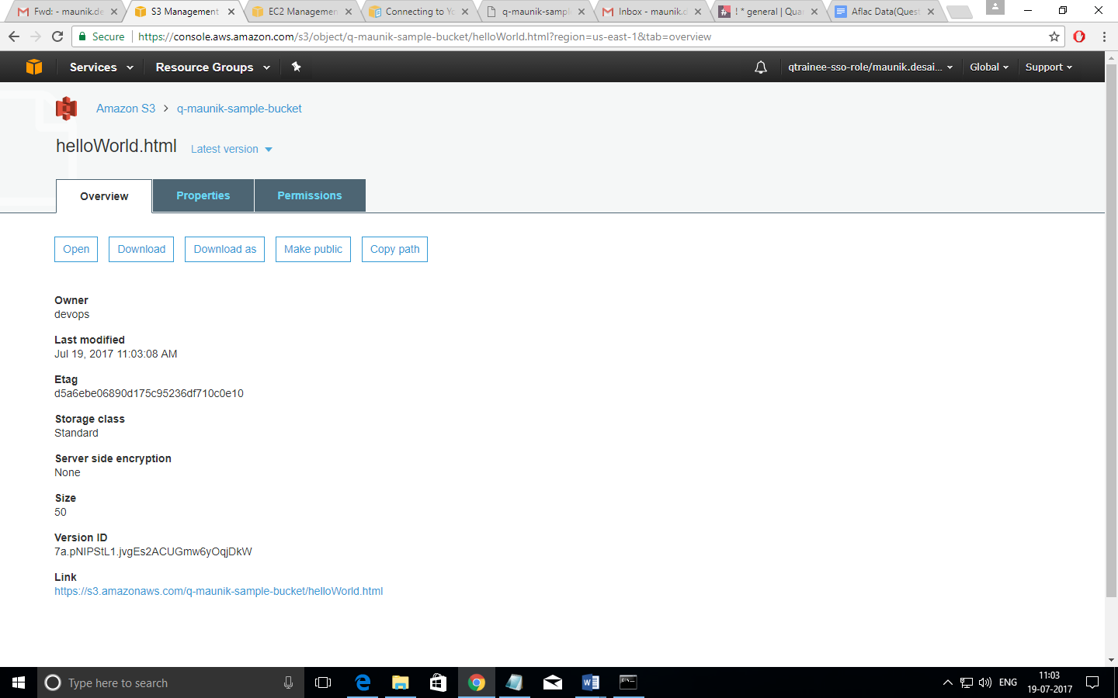

1. Click on Make Public to make it available to public for viewing
2. Go back to your bucket list
3. Click on Properties and select Static Web Hosting

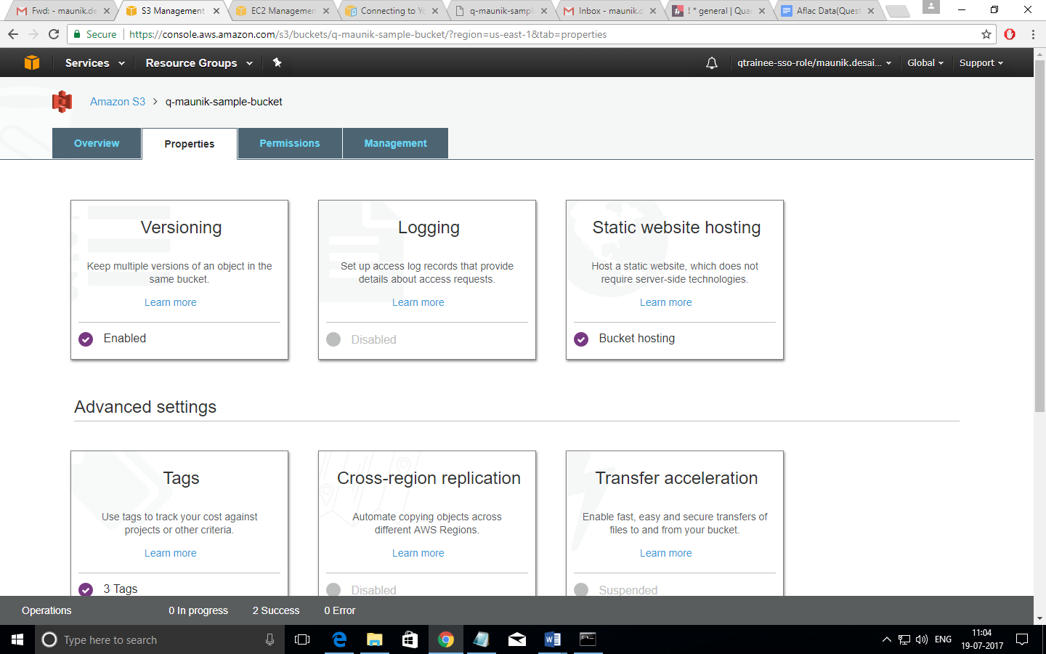

1. Enter the name of the .html file in the Index Document

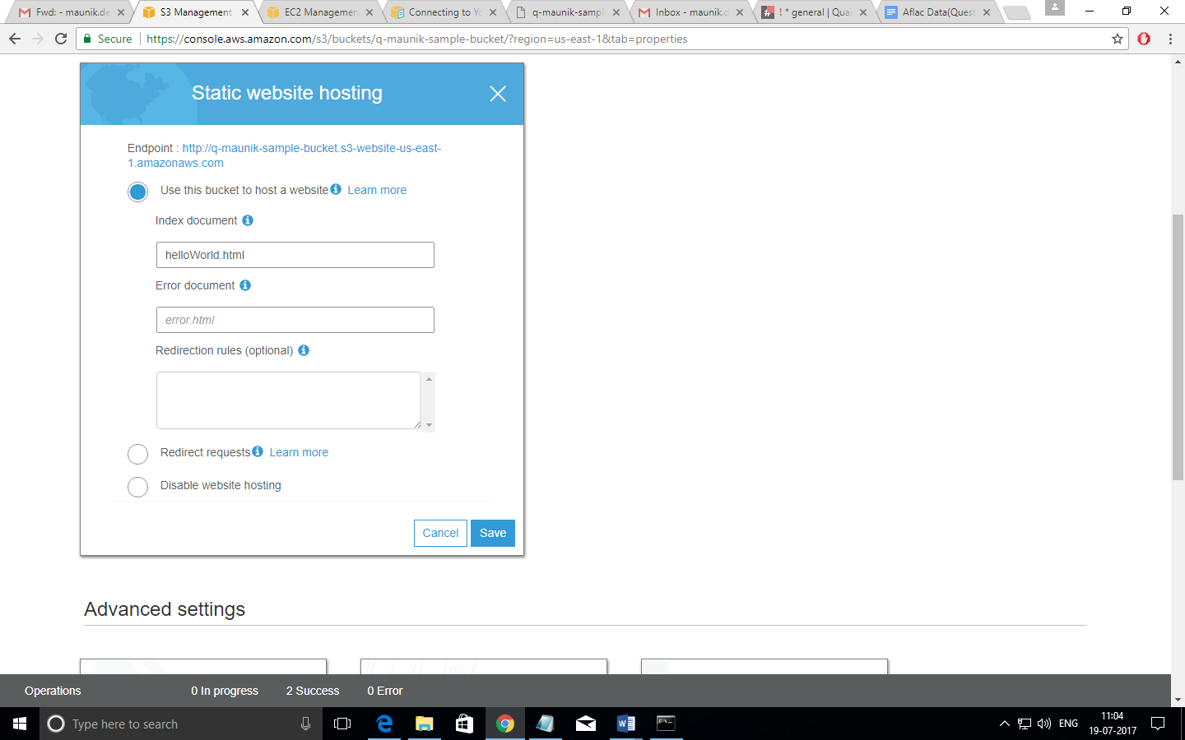

1. Click on the Endpoint Link to view your file

